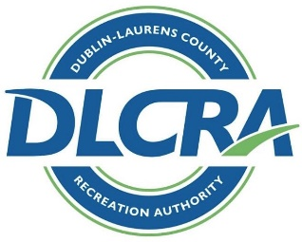 COACHES APPLICATION

PLEASE CIRCLE THE SPORT YOU WANT TO COACH:
BASEBALL SOFTBALL SOCCER FOOTBALL TRACK OTHER

PLEASE “X” YOUR COACHING AVAILABILITY:
Are you interested in being a head coach? _______ Or/and assistant coach? _________

Desired League ___________________________________________________________________________

NAME _____________________________________________________________________________________________________________________
Last First

PHONE ____________________

EMAIL ADDRESS ______________________________________________________________

SHIRT SIZE : AS AM AL AXL AXXL AXXXL Please circle one

Your Child’s Name________________________________________________________________

Assistant Coach: (1 ONLY)____________________________________ (MUST HAVE COACHES APPLICATION TO PROTECT CHILD)

Asst. Coaches Childs Name:_____________________________________________________ NOTE: Football may have (2)

Have you ever been refused volunteer participation in any other youth sports program (Circle one) Yes No
If yes, please explain: ______________________________________________________________________________

Do you hold a coaching certification? (Circle one) Yes No If yes, please list __________________________________________

If no are you willing to become certified (Circle one)? Yes No

Have you coached in youth athletics in the past? (circle one) Yes No
If so, when/where?_______________________________________

Do you hold current certification in First Aid or CPR? __________________________________________________

Do you have any special training in the youth sports field? _____________________________________________

*A Nationwide Criminal Background Check is required from all of our coaches. (DLCRA has contracted with SSCI for background checks)

